Description
This unique Cut the Crap “Candidate Packet” will replace the traditional application and will tell a clear and compelling story about why you are the best candidate for that specific position. You will be doing the hiring manager’s job for them. Their job is to compare multiple applicants and assess who will go into interviews, who is best qualified, or who they want their recruiter to call. The fact that you are doing such a thorough job with this new “Candidate Packet” application will differentiate you from the rest of the pack.

There will be three components to your Candidate Packet that is uniquely written for each job application. In order:

- 1. New Cut the Crap (CTC) Cover Letter
- 2. New Cut the Crap (CTC) JD Profile (Job Description Profile)
- 3. Résumé
How to put the “The Candidate Packet” together:
“The Candidate Packet” is a sandwich with three components in the following order: (1) cover letter, (2) JD Profile, and (3) résumé.
All three documents should be written in Microsoft Word and put together in one document as one electronic file. Why one file? First, it saves the hiring manager or recruiter time versus opening up three separate documents. Most importantly, many websites only allow you to attach one document to their website. Your single document can be “the Candidate Packet.” However, if a website clearly says “attach résumés only,” then you need to only send in your résumé.
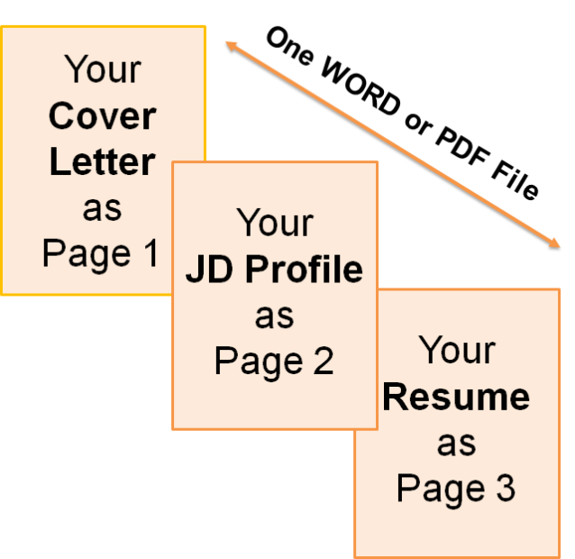

The following is a sample:
SAMPLE: Page 1: your CTC Cover letter

Mark L. Delany 13499 SE 54th St. 123.456.7898
Seattle, WA 98111 name@outlook.com

<Company>
<Address 1>
<Address 2>
<City, State, Zip>

Dear <Name or “Hiring Manager”, <date>

I would like to express my interest in the <Title> position, Job #<###> at <Company>. <Company’s> technology, since its inception, has been an area that I have followed with interest. Your business is revolutionizing <inventory, supply chain management, and loss prevention>.

After comparing your job description with my background, and doing further research on <Company> and its role in the <industry name> industry, the following are the three main reasons why I believe I am a highly qualified candidate:

<Title> Requirements | <Your Name> - Qualifications
Business Strategy and Business Investigations Expertise | - Business Strategist during the past 12+ years  - Leadership and problem solving abilities delivered results within multiple groups  - My attention to detail lead to the attainment of my organization’s overarching goals.  - Excellent financial modeling and merger/acquisitions skills
Project Management and Cross Team Collaboration Excellence | - Leading and managing many concurrent projects involving multiple stakeholders.  - My core strengths are ensuring collaborative buy-in from team members on project vision, attaining goals and objectives, and meeting the success criteria in a timely and organized fashion.
Highly Motivated and Results Driven | - Received Gold Star and other forms of recognition in last 5 years.  - MBA, Complex Problem Solving training and Dale Carnegie workshops  - Constant themes of my career have been focus, drive and results.

As the above illustrates, I have solid experience that relates directly to the skills and experiences you are looking for. My objective is to bring these strengths to the <title> role and add immediate value to the <Company> team. I look forward to interviewing for this position at your earliest convenience.

Thank you for your time and consideration,

<Full Name>
<e-mail address>
<phone>
<Title>  Position ####### | Mark L. Delany, Candidate
Job Specifications from JD | Qualifications, Experience
Business Strategy and Business Investigations Expertise | - Business Strategist during the past 12+ years  - Leadership and problem solving abilities delivered results within multiple groups  - My attention to detail lead to the attainment of my organization’s overarching goals.  - Excellent financial modeling and merger/acquisitions skills
Project Management and Cross Team Collaboration Excellence | - Leading and managing many concurrent projects involving multiple stakeholders.  - My core strengths are ensuring collaborative buy-in from team members on project vision, attaining goals and objectives, and meeting the success criteria in a timely and organized fashion.
Highly Motivated and Results Driven | - Received Gold Star and other forms of recognition in last 5 years.  - MBA, Complex Problem Solving training and Dale Carnegie workshops  - Constant themes of my career have been focus, drive and results.
Global customer experience; experience working with international customers and building global strategies | - Proficient in Spanish  - 10+ years living and traveling internationally.  - Sensitive to and understanding of cultural communication differences.  - Built a China Strategy for <company>, resulting in a X% increase in revenue year-over-year and Y% increase in volume.
Fluency in Microsoft Outlook, Excel, and PowerPoint (pivot tables) and Salesforce.com or other customer relationship management (CRM) system. | - Fluency in Outlook, Word and PowerPoint.  - Registering for a class right now on Advanced Excel to become fluent in pivot tables.  - Heavy user of Salesforce.com currently and able to learn other CRM solutions.
SAMPLE: Page 2: your CTC Job Description (JD) Profile

Mark L. Delany 13499 SE 54th St. 123.456.7898
Seattle, WA 98111 name@outlook.com

SAMPLE: Page 3: your Resume

Mark L. Delany 13499 SE 54th St. 123.456.7898
Seattle, WA 98111 name@outlook.com

Professional Profile

Marketing professional with extensive experience in the technology industry. Leader and team builder. Recognized consensus builder, collaborator, and communicator. Known for quality execution, performance under pressure, and delivery in the face of ambiguity.

Competencies | Departments |  | Industries
- Business Strategy Development and Implementation | - Marketing |  | - High-Tech
 | - Sales |  | - Entertainment/Gaming
- Program/Product Management | - Operations |  | - International Logistics
- Partner Relationship Management | - Manufacturing
- Channel Development/Key Accounts

Professional Experience

<XYZ Corporation> – Kent, WA 2006 – Present

Senior Marketing Manager
Strategy, design, and implementation leader for 6 global marketing programs with a $3 million budget.
- Owned the operating budget of $3.1 directly; regularly met <1% variance targets and drove efficiencies across all marketing functions.
- Managed team of 16 people across support, marketing and customer service.
- Won 2 ‘World Class Marketing’ awards – one for vendor management and one for creativity.
- Initiated regular business monthly process for all major account teams to review their marketing plans.
- Guided a global virtual team across Operations, Finance, Legal, Policy, IT, Marketing, and Sales; recognized for cross-group collaboration.

Senior Product Manager
Owner of two marketing programs with the <division>
- Through Partner Marketing – Designed and implemented a suite of global, self-service applications supported by 1,500 partners who executed customer campaigns.
- Partner Learning – With monthly totals of roughly 100,000 visits and over 45,000 learning activities completed, this global application provides the central training portal for partners.

- Worked with the marketing and sales field teams to drive worldwide adoption of Partner Marketing Center (through 43 subsidiaries).
- Led virtual, global teams spanning Marketing, Legal, Operations, Engineering, Vendors, and Field representatives.
- Engaged partners in major regional events and focus groups.
- Acted as the primary liaison between business partners and engineering teams to identify, prioritize, scope, and document business requirements; trusted advisor to business executives.
- Earned recognition as an expert in managing broad virtual teams where success depends on influencing without direct authority – strong cross-group collaborator.
- Completed Six Sigma Green Belt course along with additional process training.

Manufacturing Classics, Inc. – Seattle, WA 2002-2003

Logistics Manager
- Coordinated national and international fulfillment during a period of 125% growth while managing a 13,000 ft warehouse staffed with up to 20 temporary laborers.
- Developed detailed proposal and project implementation plan to bring fulfillment in-house by opening a new facility which then handled over $X million in orders during the first 6 months.

Consultant 2000-2002
Data analysis, research, business plans, and process improvement for various companies.

Express Software Corp. – Seattle, WA 1998-2000

Director of Sales and Marketing
- Managed vendor relationships with marketing and ad firms to guide production of marketing collateral, internet site design/content, public relations documents, and trade show visuals.
- Owned channel development for 100+ resellers and developed a marquee customer program.
- Revitalized sales of older product lines to increase revenue by over 150%.
- Drove venture capital pursuit while administering the launch
- Managed 5 direct reports programming in C++, Java

Education

UNIVERSITY OF WASHINGTON BUSINESS SCHOOL – Seattle, WA
    - MBA, Technology Management 2005
    - BA, Business Administration – Marketing Concentration 1997

Get many more tips from a hiring manager here:
http://www.danamanciagli.com/

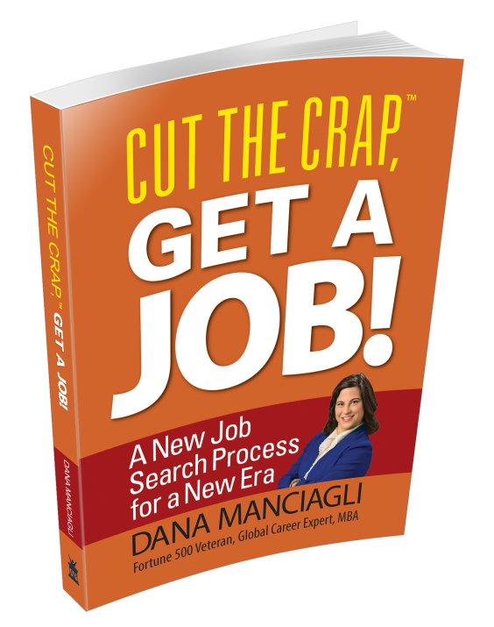

Let’s connect on:
Website blog: http://DanaManciagli.com
LinkedIn: http://linkedin.com/in/DanaManciagli
Twitter: https://twitter.com/DanaManciagli
Facebook: https://facebook.com/DanaManciagliCareerCoach
YouTube: http://youtube.com/user/CutTheCrapGetAJob
Pinterest: https://pinterest.com/DanaManciagli
Google+: https://plus.google.com/b/106167442167068566394/
RSS: http://danamanciagli.com/feed

